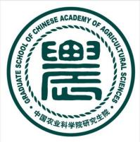 | 中国农业科学院研究生院国际学生学习计划  Study Plan of GSCAAS International Applicants

请用中文或英文撰写
Please write your study plan in Chinese or English
姓 /Surname |  | 名/Given name
国籍  Nationality |  | 护照号  Passport No.
申请类别  Category of study | 博士研究生PhD 硕士研究生Master 进修生Visiting scholar
申请专业
Major of application
个人情况介绍Personal Introduction
教育背景Educational background
学术经历和成果 Academic experiences and achievements
来华学习意愿Motivation to study in China
研究计划Research plan in GSCAAS （不少于1000字 not less than 1000 words）
需描述项目题目、背景、研究目标、研究内容、研究计划、预期产出及参考文献 Description of project title, background, objective, research content, work plan, expected outputs, and reference.

毕业后的发展目标Plans or goals after graduation
申请人承诺意见/ Applicant’s commitment
我承诺以上表格中的信息和资料完整、真实和有效。
I hereby declare that all information and materials in the form are true, complete, and accurate.

申请人签字/Signature： 日期/Date:
接收导师意见/ Signature of applicant’s supervisor
申请人导师对研究计划进行评估，简要描述拟指导申请人开展的研究工作（中文）
The applicant’s supervisor evaluates the Study Plan, gives a brief description of applicant’s research arrangements (in Chinese).

接收导师签字（中文） ： 日期:

